September 2025

School of Computer Science and Informatics, Cardiff University

Supervisor: Alia l Abdelmoty  
MSc Advanced Computer Science

Development of a Web Application for Visualising Geospatial Knowledge Graphs

Author: Georgio Zeilaa - C23101178

Acknowledgement

Abstract

To create a website that visualises the geospatial knowledge graph by utilising various features including maps, tables, and detailed panels. There are different approaches to this problem, choosing the most appropriate solutions would be done by researching existing products and choosing wisely the most suitable features, keeping in mind that future expandability would be needed. Designing the website project to implement features with scalability is a factor hence a plan must be in place to satisfy scalability. Exploring the features implemented by testing them with comparisons made with the original geospatial knowledge graph data would mean a better result for the project where solutions were implemented and explored of how well they are implemented. At the end, concluding how well the website runs with the features added and more featured that can be added.

Chapter 1: Project Statement, Aim, and Objectives 5

1.1 Introduction 6

Chapter 2: Literature Review 7

2.1 Introduction to knowledge graphs 7

2.2 Existing web applications for data visualisation using knowledge graphs 7

2.3 NoSQL Databases 8

Chapter 3: Background 9

3.1 Choosing a web framework 9

3.2 ReactJS 9

3.2.1 Examples of map components 9

3.2.2 GUI components 9

3.3 Neo4j to manage and store the data 10

Chapter 4: Design 11

4.1 Overview 11

4.2 Requirements 11

4.2.1 The data provided 11

4.2.2 Use Cases 12

4.2.3 GUI 12

4.3 Modelling 13

4.3.1 Data modelling 13

4.3.2 Graph models and Use Cases 14

Chapter 5: Implementation 15

5.1 Programming Language 15

5.2 Version control 15

5.3 Neo4J 15

5.3.1 Importing data 16

5.3.2 Cypher query 22

5.4 ReactJS 25

5.4.1 Use cases implementation 30

5.4.2 Neo4J Driver 31

5.4.3 React-Leaf 33

5.4.4 DeckGL 34

Chapter 6: Analysis and Testing 36

6.1 Analysis 36

6.2 Testing 38

Chapter 7: Evaluation & Conclusion 42

7.1 Evaluation 42

7.2 Conclusion 43

Chapter 8: Future Work 44

Chapter 9: Reflection 45

References 46

List of Figures 48

Appendices 50

Appendix A - GitLab Project, contains the converters, ReactJS webapp, csv, json files, instructions on how to run the project 50

Appendix B – Gantt Chart, project plan 50

Appendix C – Meeting notes 50

# Chapter 1: Project Statement, Aim, and Objectives

**Project statement:**

To produce a webapp that provides different ways of visualising the geospatial knowledge graph.

**Aim:**

To be able to produce a webapp that visualises the geospatial knowledge graphs with different types of visuals.

**Objectives:**

* To understand what it takes to create a webapp that previews the geospatial knowledge graphs.
  + Background research on existing solutions of the current problem.
  + Attempt to use an existing webapp that has a similar solution.
* Compare different types of visuals that represent the geospatial knowledge graph.
  + Produce a solution for each visual type.
  + Analyse and compare the outcome of each visual type.
* Compare webapp frameworks.
  + Research webapp frameworks that work best for visualising knowledge graphs.
  + Implement a webapp framework with geospatial knowledge graph visuals.
* To test the webapp with knowledge graphs loaded.
  + To test the functionality of the webapp.
  + To explore how well it is for the mobile screen size and how this can be done in the future as an improvement.

## 1.1 Introduction

Knowledge graphs are a representation of organised information so that concepts such as people, places, or objects are represented as nodes and the relationships between them are represented as edges. Focusing on geospatial knowledge graphs which represent places and connection between them.

The data represented would need to be in a form of database that is able to extract data whenever a result is requested. Researching existing databases that work best with geospatial knowledge graphs is one key point to achieve in order to produce a working database.

Producing websites can be done in a lot of various ways hence looking into what can be the best choice for this project which makes use of the geospatial knowledge graph database plus the graphical user elements which needs to be implemented as well. The graphical user elements would represent the geospatial data visually. This can be in various forms of visualisation.

Looking at existing products that represent a geospatial knowledge graph in a website, this would help the project in implementing visualisation features on the website. Adding more features would be explored when it comes to meeting the aim by following the objectives.

Checking the solutions implemented to make sure they function as intended and they are correctly outputting results that are accurate. This will be done by comparing results on the website with the chosen database. Making sure that there is a base line of accurate results which is in the database. This helps in making a fair comparison.

Future improvements are possible since this project focuses on the proper implementation of the website with scalability in mind. This assists the project code in expandability by being able to add more features or expand on existing features.

# Chapter 2: Literature Review

## 2.1 Introduction to knowledge graphs

Knowledge graphs represents real world knowledge for example a map with cities and countries. One country can be close to another country and that country has multiple cities. The connection between the two countries (nodes) can be the direction of where the other country is, this is called an edge (the connection). Knowledge base was used a long time ago, it was used in the 1970s reasoning and problem solving, MYCIN. This had 600 rules based on an expert system for medical diagnosis. The concept of a knowledge graph gained popularity when google search engine introduced their knowledge fusion framework called knowledge vault. (Ji et al., 2022) The knowledge vault is meant to get information from various sources across the web, this can be people, places, organisations which are in the knowledge graph. (support.google.com, n.d.)

## 2.2 Existing web applications for data visualisation using knowledge graphs

Kepler.gl provides various ways to load geospatial data onto a map. The data can be in a form of files, URLs, or load from cloud storage such as google drive. Once the data is loaded, there is a filter option where it can show data if a value is higher than a specific number. For example, loading the new york city taxi data, there is a field called passenger_count which can be used to show specific number of passengers who used the taxi in new york. (kepler.gl, 2019)

Kepler is built on react and redux web framework technologies, the project also has embedded ability so it can be added to other websites as a small sized window to view the map with the loaded data points of your choice. The project is available on GitHub and it is open source, it is built upon mapbox which is a paid service that provides maps, navigation, and more. Kepler can also be integrated into react web projects by installing it as a component. (kepler.gl, 2019)

Using kepler.gl,

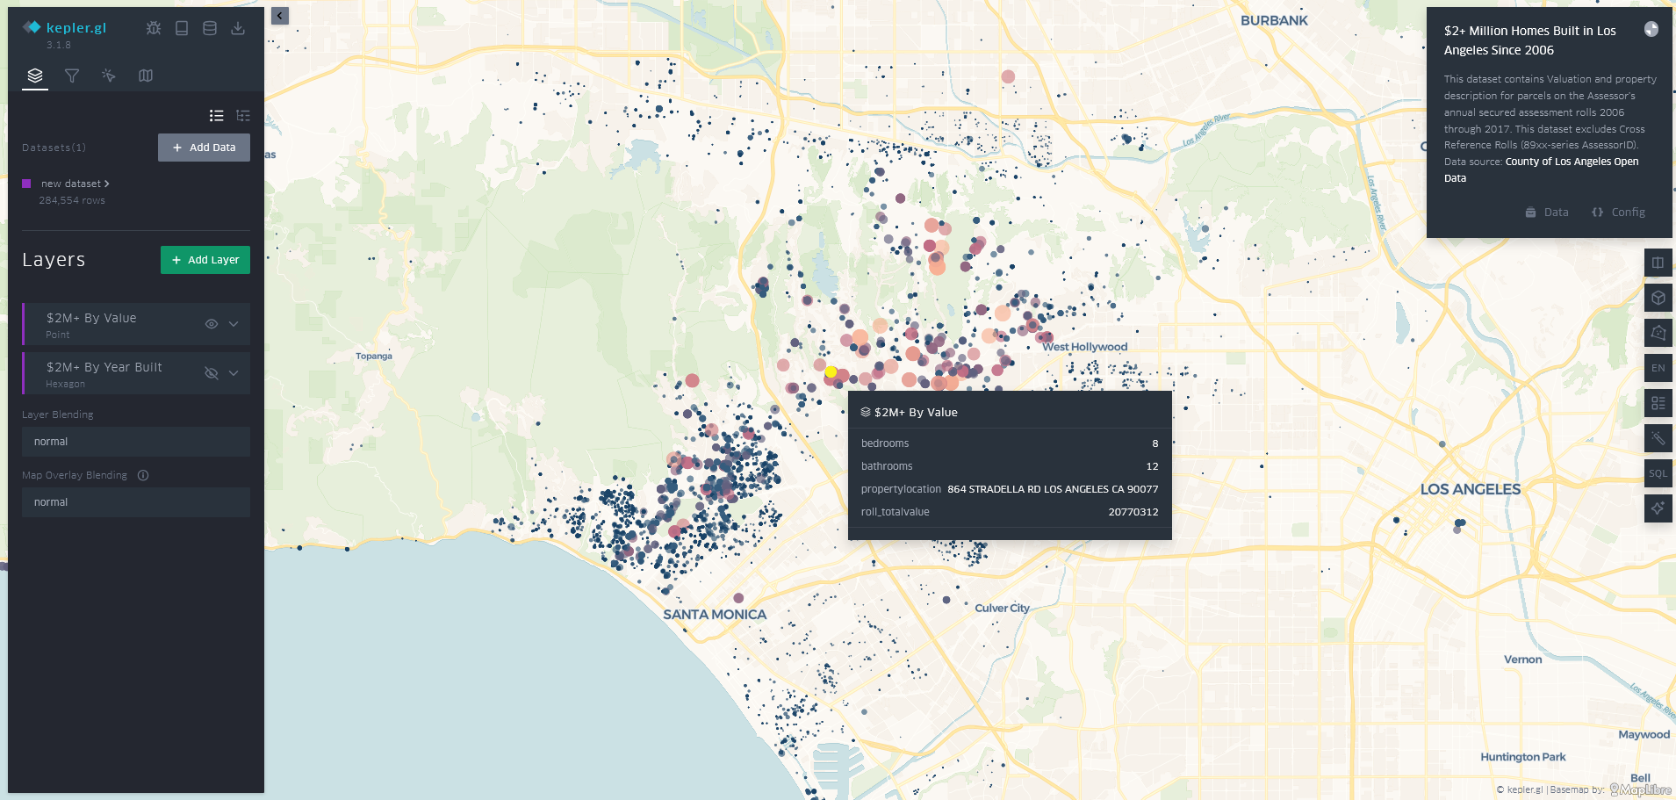

Figure Sample data loaded in Kepler.gl

The above figure shows data points loaded onto a map. Those data points are a sample of data which represents the “$2+ Million Homes Built in Los Angeles Since 2006”. When clicking on one of the points on the map information about that point appears. It shows information about the house built such as, number of bedrooms, bathrooms, the location of the property (address) and the total value.

One the left-hand side there is a panel that allows for filtering, adding more layers such as a line between two points. In the figure below, there is an option for hexagon layer to show the year built by having a different colour represent 2 years incrementally.

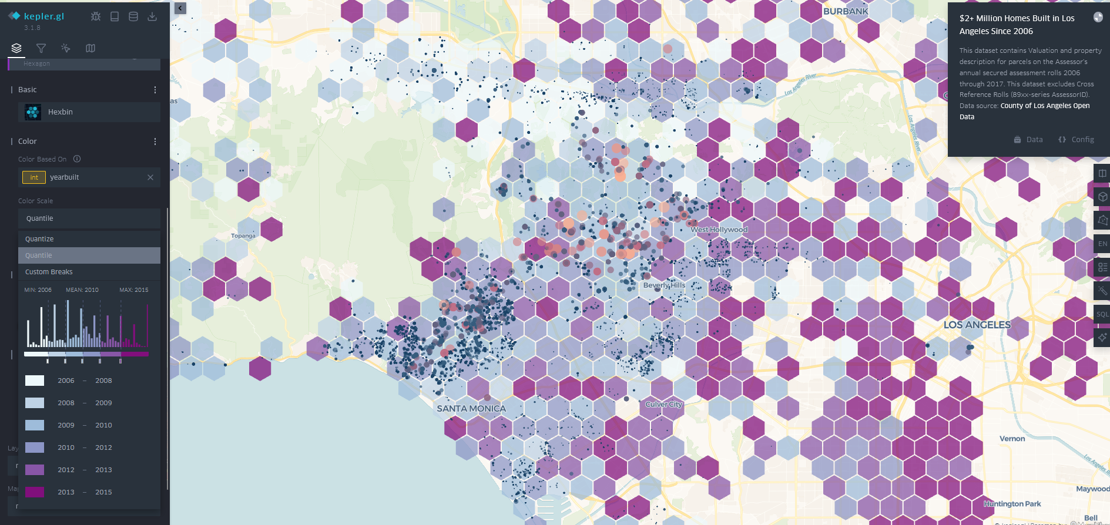

Figure Layer example in Kepler.gl

## 2.3 NoSQL Databases

This is a graph database management system, this allows the use of knowledge graphs to be stored and utilised in Neo4J.

The paper “State-of-the-Art Geospatial Information Processing in NoSQL Databases” goes in depth into NoSQL databases, including Neo4J. Neo4J offers feature specific to knowledge graphs such as specific functionality to traverse through the graph in an efficient manner. It even has a spatial feature called Neo4J Spatial, it offers support for seven geometry types: point, linestring, polygon, multipoint, multilinestring, multipolygon, and geometrycollection. This indicated as to how in depth the feature Neo4J has to offer and how powerful this tool can be when used with geospatial data. There are other options than Neo4J, an example is MongoDB, this is also a NoSQL database, it has some advantages which include the queries of “within” and “intersection” in their time to take to load.

The query language that is used in Neo4J is cypher, it is SQL-like but graph oriented, it is easy to understand since it is readable and expressive. MongoDB uses JSON based syntax which can be more difficult than cypher in Neo4J since it can get verbose and nested. (Guo and Onstein, 2020)

# Chapter 3: Background

## 3.1 Choosing a web framework

Why ReactJS and how it can be used to show knowledge graphs and components:

<https://blog.tomsawyer.com/react-js-graph-visualization>

Choosing a web framework to run the visuals of the geospatial knowledge graph data need to be optimised for reliability and versatile. Reliability when it comes to speed of loading the webpage and versatility in terms of flexibility when it comes to adding features to the website by using existing components. Components are an example of plugins, for example it can be react leaf which is a map library that can be added to a ReactJS project, this helps speed up the development time. ReactJS uses JavaScript language, this helps by having the code modular, simple to use, and having a strong community by having third party libraries widely accessible to ReactJS. Compared to other frameworks such as vue or angular, angular was actually faster than ReactJS according to Redware study. Overall, this is a compromise in potential speed loss versus the flexibility of the community support and reliability is a trade-off that might be worth making. (Rajiv Tulsyan et al., 2024)

## 3.2 ReactJS

### 3.2.1 Examples of map components

An example of where ReactJS was used with geospatial knowledge graph an article titled: “GeoGraphVis: A Knowledge Graph and Geovisualization Empowered Cyberinfrastructure to Support Disaster Response and Humanitarian Aid”. It provides the use of ReactJS with a third-party library called DeckGL for adding a map to the website to load the data visually see it. It allows the selection of data variables on the map and filter options. It is used in the article to filter by disaster type and ability to view the results as a bar chart. (Li et al., 2023)

Another example of a ReactJS map component is react-leaf, this is an open source project which provides map component for ReactJS and other frameworks. It is quiet simple to implement compared to DeckGL since it has 2D rendering and it’s great for small to medium sized data. It has basic maps and interactive UI but not as detailed as DeckGL with its 3D maps and animated features. (react-leaflet.js.org, n.d.)

### 3.2.2 GUI components

GUI components in ReactJS are very helpful in terms of the plug and play capabilities. Normally a developer would need to develop a CSS file, this file contains the styles that will be used in the webapp which in this case would be ReactJS. Using libraries such as MUI, this can help the developer in spending less time worrying about the styles and more time developing other parts of the webapp. GUI components that would be suitable for this project would need to have components such as a table, preferably a collapsible one too. This will then be able to hold more data than just a regular table. MUI which is implements Google’s material design with pre-built component set, the package offers highly extensive theming support and robust community with documentation. There are other options as well, a lot of them offer similar options to MUI however MUI seems to be the most polished component library where it offers a lot of components that should meet the project’s aim and objectives. (Giri, 2024)

## 3.3 Neo4j to manage and store the data

Neo4j is a NoSQL, this is an example of an advanced and flexible database system. NoSQL is not only structured query language, it is used for when the normal relational database structures are too limited for the use case scenario, for example a knowledge graph is well represented when stored in Neo4J since it can store graph database. Neo4J uses Cypher as its query language which makes relationship querying intuitive compared to SQL by having simpler and more understandable querying syntax. When it comes to traversal, it is much quicker to hop from one node to another using Neo4J than the traditional SQL join clause. (Google Books, 2025)

# Chapter 4: Design

## 4.1 Overview

The program will be designed to contain two types of geospatial visualisations of the knowledge graph data. These will be points on the map with edges connecting those points. The two types of visualisations will be in the form on ReactJS components, one is ReactLeaf, and the other is DeckGL.

Understanding the data provided and then modelling them is important. By modelling the data, this will enable the queries which are in the form of use cases to be ran quicker than just using a general data model.

After producing the data models, graph models will be put in place using Neo4J. Then to produce a graphical user interface on the ReactJS webapp that meets the requirements.

## 4.2 Requirements

### 4.2.1 The data provided

The data provided are in the form of csv format. There are 6 files which contain the following:

* SF_List
  + It contains the spatial features (SF) such as buildings, malls, landmarks, etc. This includes both geographical coordinates and semantic classifications.
* ED_SF_OtherPoints_Containment
  + Contains the relationship between electoral divisions (EDs) and spatial features like railway stations, buildings, or other local points of interest.
* ED_Wales_ProximityData
  + Contains directional adjacency graph between electoral divisions.
* SF_OtherPoints_ProximityData
  + Contains directional proximity relationships between spatial features like buildings, transport points, landmarks, or even businesses.
* UA_ED_Containment
  + Contains administrative hierarchy: which Electoral Divisions belong to which Unitary Authority (UA).
* UA_Wales_ProximityData
  + Contains the directional proximity relationships between Unitary Authorities.

Overall, the files collectively represent a multi-layer geospatial knowledge graph, compromising of spatial features, electoral divisions, unitary authorities. Along with relationships such as proximity and containment. The nodes are defined with details of coordinates and spatial features.

### 4.2.2 Use Cases

The Use Cases required to be implemented:

1. **Regional information, for example: List all places in Cardiff.**
   1. This will list all the places and points of interest in Cardiff, such as ED and shops.
2. **To search by place, type, and relationship type. For example, what hospitals are in the north of Cardiff.**
   1. Checking for hospitals in the north of Cardiff and it will use the directly connected nodes to show them too for a more in-depth output. This will list all the hospitals in the north of Cardiff.
3. **Find all types in a place. For example, find all hotels in Cardiff**.
   1. This will list all places in Cardiff with the hotel nodes connected to it.

### 4.2.3 GUI

The UI would need a map to plot the points on the map then it would require the edges which connects those points to each other if more than one point is visible on the map.

The user would require the ability to do a search using the use cases listed above so at least one input box with a search button is required. This will then update the map with the results.

Having just a map would not be sufficient for the user to have the ability to view the data differently and directly. Directly, meaning the user can read all the information about the location or locations found, this will include subjects, longitude and latitude and more. This can be in a form of table with rows and columns. If one data point meaning one location is found, then it will show one record in that table and if more than one location is found then it will list them all.

The user will be able to switch the views from the two view map components that would be implemented, which are React Leaf and DeckGL.

There will be a search feature. It will have the ability to search by entering information in an input field then clicking the search button would be a way of sending the data to Neo4J. Different kind of searches would require the GUI to implement some sort of options such as dropdown menu, this will allow the user to choose what type of search would they like to perform then the necessary input fields will appear to prompt the user to enter the data then click search.

The design which includes the buttons such as search, input boxes for the search, maps, table, and a detailed panel is shown in the figure below.

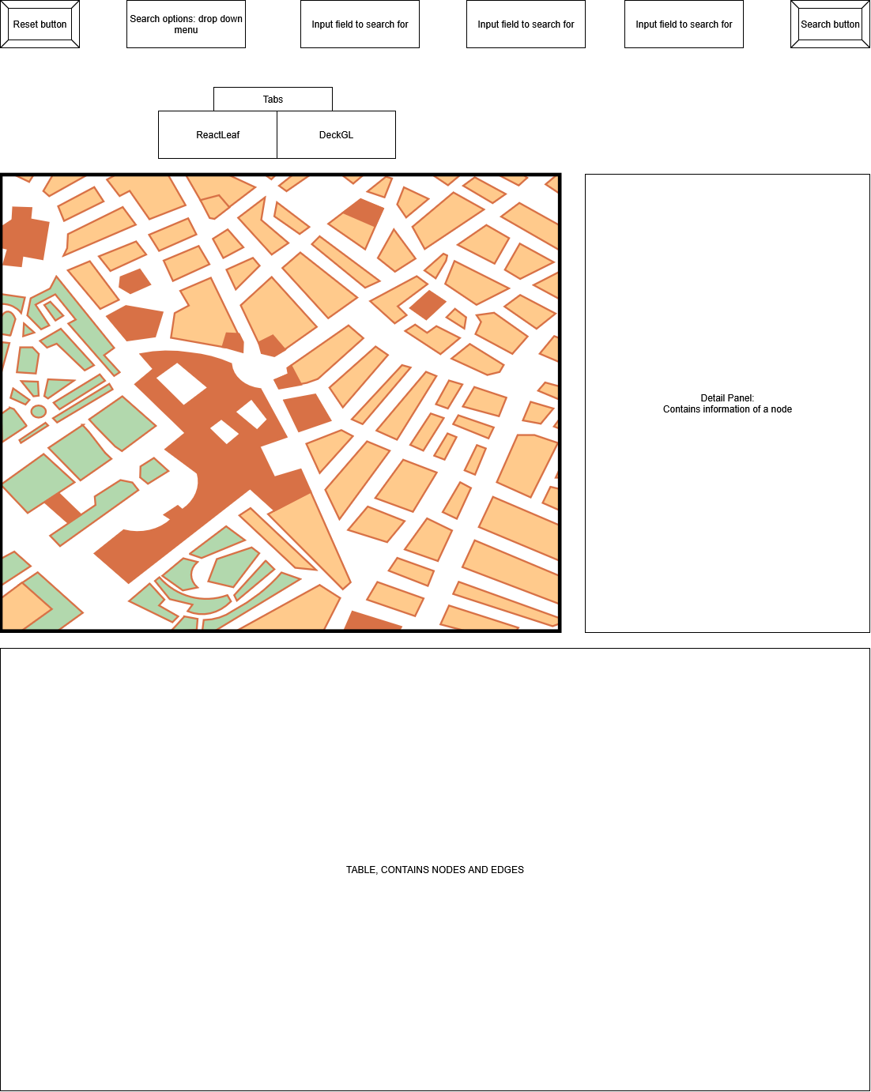

Figure Design Demo Of Website

## 4.3 Modelling

### 4.3.1 Data modelling

The data provided include nearly all the correct data needed to build a graph model. One file where the data needs to be converted to longitude and latitude is the SF_List file. The file contains X and Y labels which cannot be used in the ReactJS components such as react leaf so converting them would make it much easier to work with them plotting them on a map in ReactJS. Creating a python script to convert them and the outcome will be a new csv file with two new fields of longitude and latitude. It will use transformer from pyproj, the library is used for geographic data and converting coordinates. The data in the original csv file is in British national grid format with X and Y values, this is represented by the code “EPSG:27700” and conversion to longitude and latitude would be to the code “EPSG:4326”. (Github.io, 2019)

The below figure shows a small sample of the converted data:

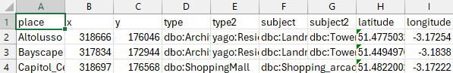

Figure Converted x and y to latitude and longitude

### 4.3.2 Graph models and Use Cases

The graph models will be created to meet the use case scenarios. There can be one data model for all scenarios however this might slow down the queries since it would be searching in a much bigger data model. Creating tailored data models for each of the scenarios can lead to the queries taking less time to process.

The general data model that contains all the data includes all the csv files and connected edges and nodes. The connected edges can either be proximity, contains or direction. This is shown in the figure below.

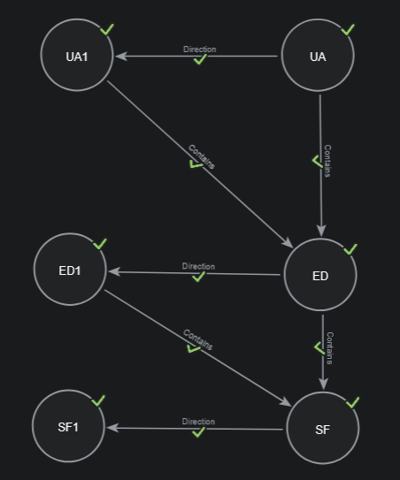

Figure Neo4J Graph Model

# Chapter 5: Implementation

## 5.1 Programming Language

Choosing JavaScript as the programming language when creating a website will help expand the project quicker due to its simplicity of the programming language. ReactJS utilises the language with a folder and code structure that is intuitive to follow. The availability of third-party libraries which are called components in ReactJS is massive. By having a massive choice of components (libraries) which will enhance the development time by having prebuilt components.

## 5.2 Version control

Using version control helps when it comes to detailed history of every change, so it is possible to see what changes are applied, where, and why. Allows the developer to create different branches, meaning control of what features are done can be separated so if there is a mistake or something new, it is on its own separated from the original working code hence experimenting can be done safely. Automation and deployment can be added, for example when having a ReactJS web app project, this can be deployed to a server for hosting when changes are detected in a specific branch. This will help in deploying the project quickly.

Using Cardiff University GitLab to store and host the ReactJS project on a private repository.

## 5.3 Neo4J

Setup of Neo4J is done using Neo4J aura, creating an instance that is for free which suits the project since it won’t need scalable options like they have in offer in the paid tiers. (Graph Database & Analytics, 2024)

The instance is running online so it is accessible from any computer around the world, if the credentials are used, figure below shows the instance running on the cloud.

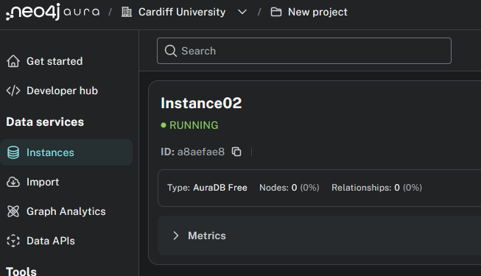

Figure Neo4J Aura Cloud Instance

### 5.3.1 Importing data

Importing data into the data sources section, this can be from another database or JSON files which is used in this project. The figure below shows a graph model with an empty data source.

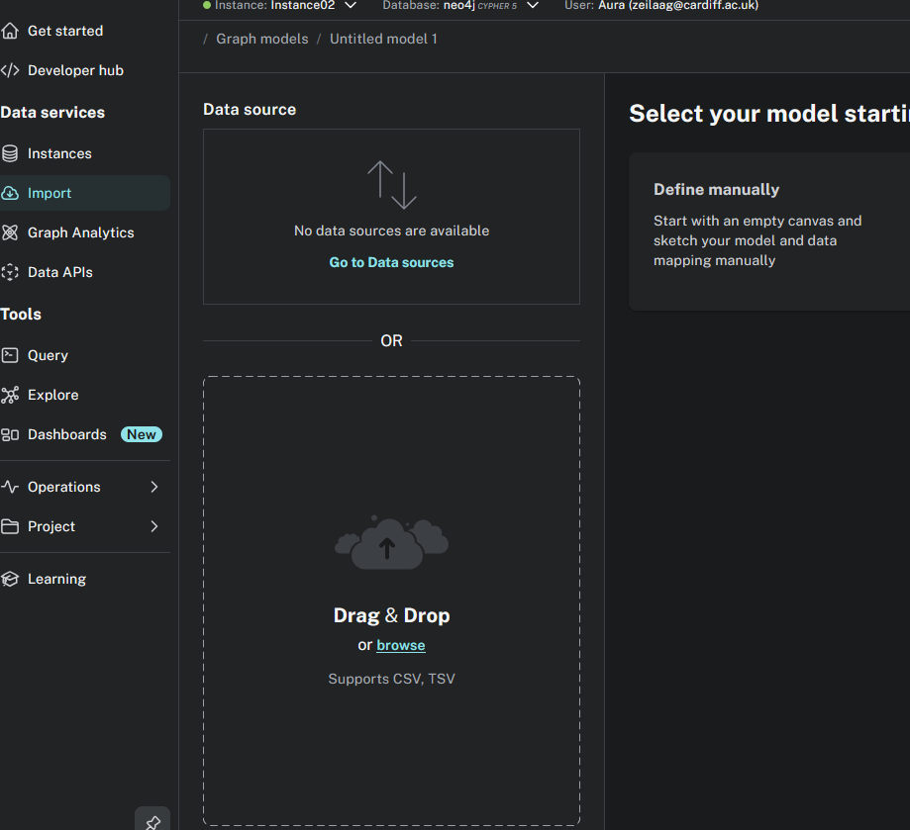

Figure Neo4J Empty Graph Model

#### 5.3.1.1 Converting CSV into JSON

Converting the csv files into two JSON files, one will contain the list of nodes, and the other will contain the list of relationships (edges).

This will help when importing them into Neo4J and it will make sure that all nodes with relationships are imported by using cypher query.

Creating a Python script to convert the csv files into JSON files. First script is to create the nodes.json file. There is a csv file that contains all the places called SF_List. This was already converted into longitude and latitude by another Python script since React Leaf component (the map library in ReactJS) cannot use the default x and y that it came with. The final csv file adds two columns of longitude and latitude. Code available in appendix A.

Since we have the places csv file now ready, converting it into nodes with the rest of the csv files since not all nodes exist as a place in the place csv file. The base of the landmarks_converted.csv file is first loaded into Python then it checks if the node is not already added, this makes sure that no duplicate nodes are added, shown in the figure below.

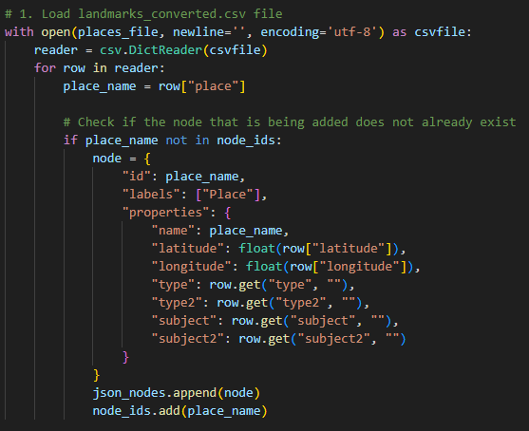

Figure Nodes Python Script Converter

Once the places are loaded, it then adds the rest of the data which contain for example shops and roads. These will not contain any longitude, latitude, type, type2, subject, subject2 hence loading them with just name is enough. These are needed to be loaded as nodes since the relationship later needs them as they are listed in there and as the graph model that was shown in the design chapter shows the relationship between them.

467 nodes are created and added into a JSON file called nodes.json.

Loading the relationships into a JSON file from all but one csv file using a Python script. The csv files must contain the relationship, for example direction and contains. The places csv file will not be used here since it only contains list of places and no relationships. The relationship JSON file will contain the from, to and type where the property of relationship will be added. The Python script also checks if there are any invalid rows, for example if the row number is not count of 3 then it will ignore and not add that row since it does not define a relationship. When running the Python script, there are no invalid rows and 2631 relationships are created. In the figure below, it shows what the template will look like in the JSON relationship file. The rest of the code is available in appendix A.

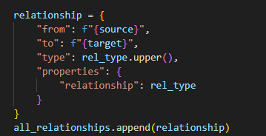

Figure Relationship Python Script Converter

#### 5.3.1.2 Loading JSON files into Neo4J

Using cypher query to load the JSON file into the cloud database instance of Neo4J will require to load it into an online accessible link that represents the JSON file, using Pastebin allows the JSON file to be accessed via Neo4J cloud database instance.

First loading the JSON file and representing the output as value and then passing the value to the create node where the labels are loaded with the id and properties then node value is passed and returned as the output. The figure below shows the full cypher query used to import nodes.json file into Neo4J.

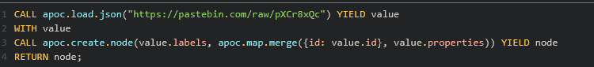

Figure Load nodes.json into Neo4J cypher query

467 nodes are loaded; this represents the same value of nodes that was created when converting from csv file into JSON file using the Python script. The figure below shows all the nodes created; this is currently without any edges.

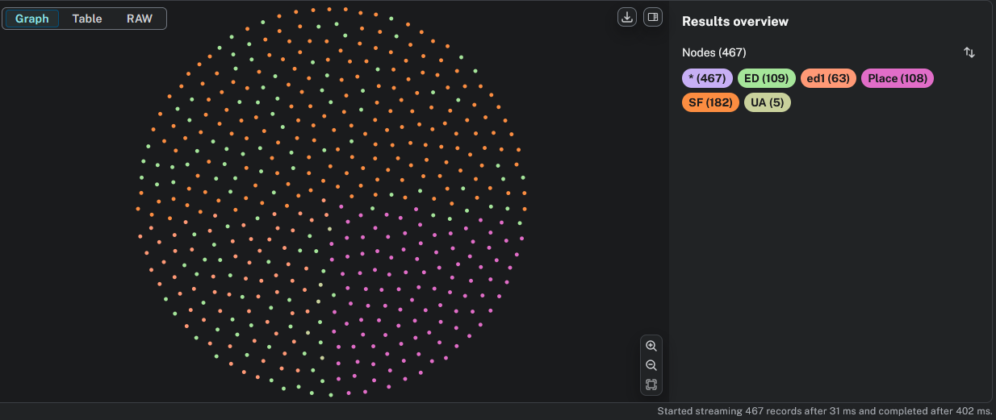

Figure Nodes in Neo4J without edges

Loading the relationships.json file into Neo4J cloud database instance required the same steps as loading the nodes.json file but with a different cypher query. The cypher query will load the JSON file from Pastebin and pass the value to then match the id with the values of “from” and “to”. Those are then passed as a, b, value. Then use of relationship will be created based on the “a”, which is “from” and value “type” which is the type of relationship, properties, and value “b” which is “to”, this is then returned to preview the results. 2631 relationships are imported and created into Neo4J; this value is the same value when creating the relationship.json file using the Python converter hence no relationships are missed. The figure below shows the cypher query.

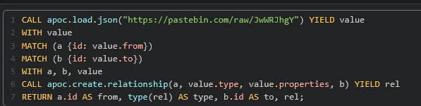

Figure Load relationships.json into Neo4J cypher query

A small sample of the output in Neo4J after the relationship.json import and creation shown in the figure below.

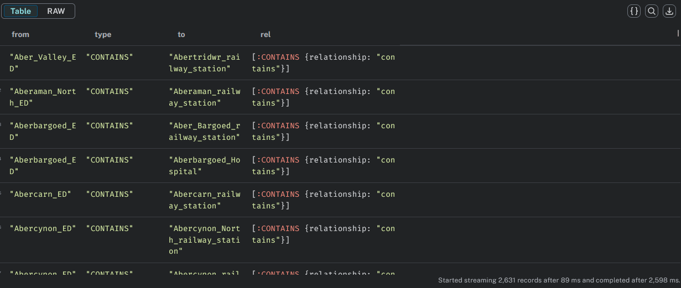

Figure Sample relationship import data into Neo4J

To show an overview of all the nodes and edges imported into Neo4J cloud database instance, running a cypher query to load all nodes and edges shown in the figure below.

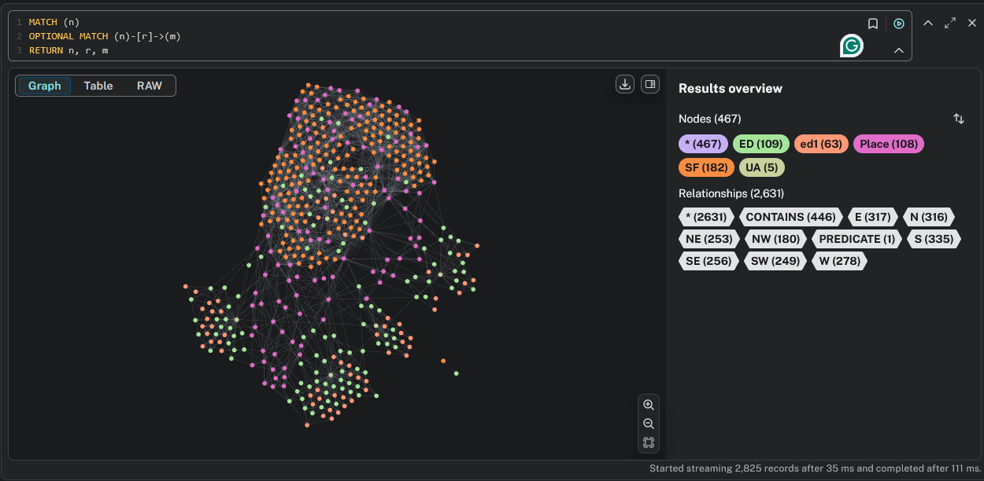

Figure All nodes and edges in Neo4J

Overall, the nodes and edges are connected however there are two nodes where they are not connected. The figure below shows a zoomed in view of the nodes by themselves.

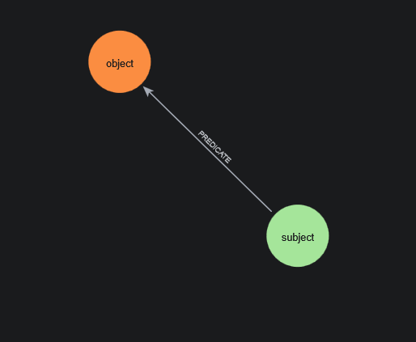

Figure Nodes by themselves in Neo4J

This was imported from the csv file into JSON and is located in ED_SF_OtherPoints_Containment.csv file. Opening the file in excel shows the incorrect data.

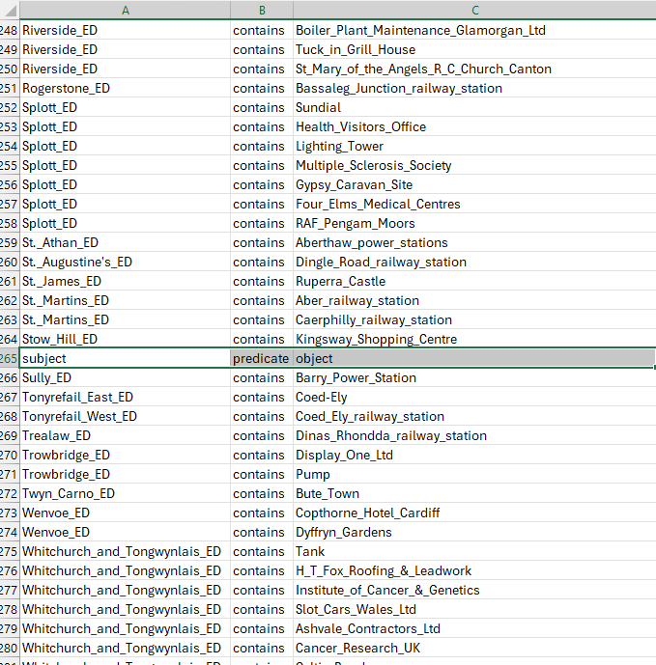

Figure Incorrect data in ED_SF_OtherPoint_Containment.csv

By removing the row, then running all the Python converting scripts and importing all nodes and relationships, the node count is now reduced by two and the relationships are reduced by one. And there is no longer two nodes and an edge by themselves.

### 5.3.2 Cypher query

To meet the use cases listed in the design chapter, the queries need to be designed to give an answer to the use cases.

The use cases:

1. Regional information, for example: list all places in Cardiff.
   1. The cypher query used:
      1. Looking at the data, it shows that Cardiff is in SF_List which is under the header place name.
      2. 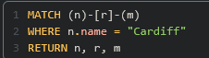

Figure Use Case 1 cypher Query

* + 1. The cypher in the figure above finds all nodes in the name field in the place “Cardiff” and it makes sure to return all the results that have connected nodes to the place “Cardiff.
  1. The outcome:
     1. 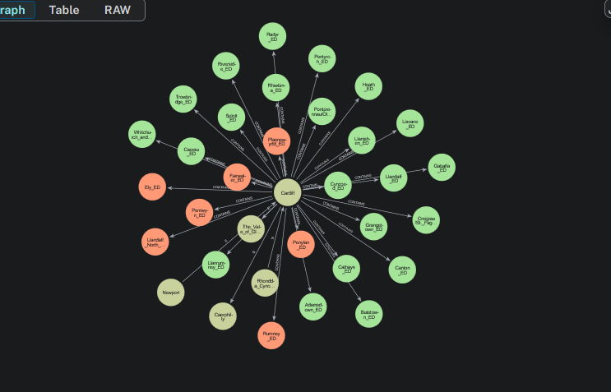

Figure Use Case 1 Cypher Query Output

* + 1. The node of Cardiff will appear first then all the direct relation nodes will appear, hence finding all the connected nodes directly to Cardiff with different relationship types since this was not specified in the cypher query.

1. To search by place, type, and relationship type. For example, what hospitals are in the north of Cardiff.
   1. The cypher query used:
      1. The data that contains the place names is in the name and subject fields, then the relationship is the North or N as saved in the data. For the type, the hospital is an example in the type field.
      2. 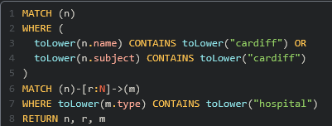

Figure Use Case 2 Cypher Query

* + 1. The cypher query returns all the nodes and edges which are related to places containing the word “cardiff” with the relationship of “N” (north), and place type containing the word “hospital”. The n is for the node of place, r is for the relationship, and m is for the place type.
  1. The outcome:
     1. 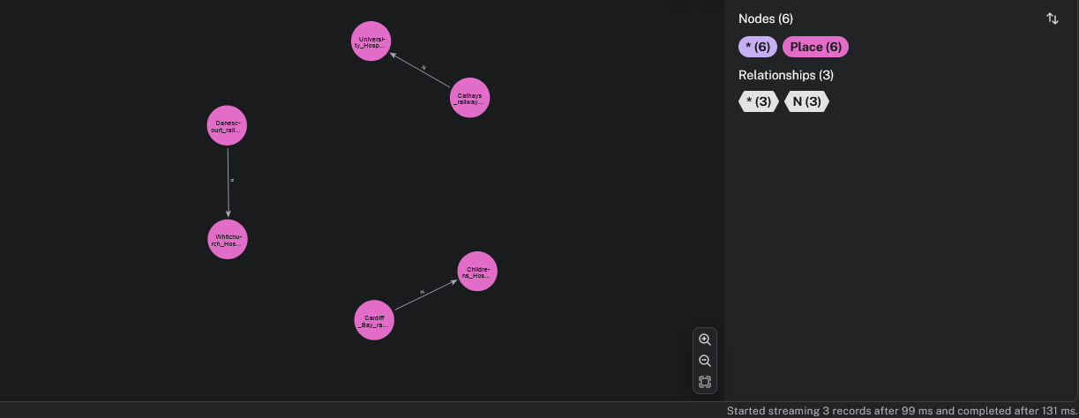

Figure Use Case 2 Cypher Query Output

* + 1. The query output shows hospitals in north of Cardiff that are connected to the north of various locations such as Cathays railway station. In total there are 3 hospitals that are in the north of Cardiff.

1. Find all types in place, for example find all hotels in Cardiff.
   1. The cypher query used:
      1. The data has the places names which will contain the word Cardiff and finding all hotels in Cardiff would mean checking the nodes that are directly related to with the name, subject, or type to contain the word hotel.
      2. 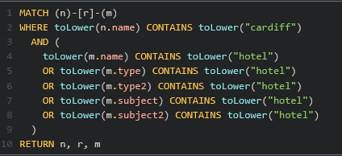

Figure Use Case 3 Cypher Query

* + 1. The cypher query searches all the places with the name Cardiff and gets the connected nodes that have the name, type, type2, subject, or subject2 that contains the word hotel. This will return a list of Cardiff nodes which connect to nodes that have the word hotel in them.
  1. The outcome:
     1. 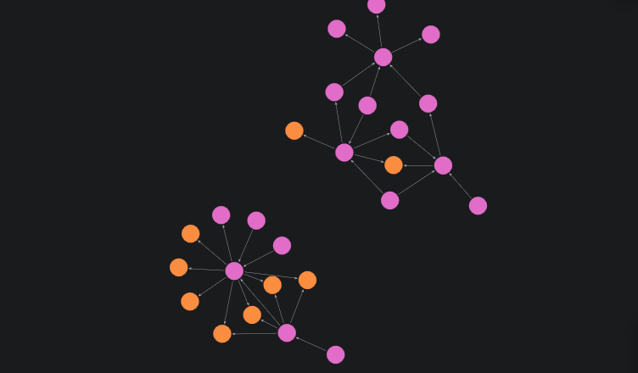

Figure Use Case 3 Cypher Query Output

* + 1. There are 5 hotels which multiple nodes connected to them. The nodes connected to them are related to the place Cardiff.

## 5.4 ReactJS

Creating the ReactJS app requires NodeJS to be installed. This can be done by downloading then installing the NodeJS installer from their official website. This can be installed on Windows, macOS, and Linux. (Node.js, n.d.)

Creating the react app by running the following command in the command line prompt: “npm create-react-app my-app”. This will download all the necessary files to get started. It will have an organised structure that we can follow later when adding more files to the website. (Create-react-app.dev, 2019)

The design library with UI components that is going to be used is called Material UI. This will represent the input boxes, search buttons, tables, and any other UI components except for the maps. Choosing this library since it is free to use and offers wide variety of UI elements such as sliders, tables, dialogs, and more. The UI components are highly responsive hence having a mobile friendly UI would become much easier. Customisations of the UI elements is also possible by adjusting size, colour, and actions such as on hover colour and effects. Adding the MUI component requires some packages to be installed, running the following command “npm install @mui/material @emotion/react @emotion/styled” installs all the necessary packages. (mui.com, n.d.)

The UI components used to meet the UI design requirements will be buttons, input boxes, and tables. The button would be used for to click search. The input boxes would be required to contain value, for example a place. If a value is there, then it will send it with the cypher query to Neo4J to process and output an answer. Once the answer is received from Neo4J in ReactJS, the data will be processed to be added to the map of both React Leaf and DeckGL, and table component which is from MUI.

The overall structure of the ReactJS project code would follow the possibility of creating a component to separate the code wherever possible. There are 4 folders created in src. The folders are:

Components:

* Collapsible Table
  + The table below the map, this shows the list of nodes and edges.
* Detailed Panel
  + Showing the information about a selected node from the map.
* Input Form
  + Search types and input fields with the search and reset buttons section.

Pages:

* DeckGL
  + Containing the DeckGL component.
* Map Tabs
  + Two tabs where it switches between the two map components available.
* ReactLeaf
  + Containing the ReactLeaf component.

Secrets:

* Credentials Neo4J
  + Contains the login information needed to connect to Neo4J database.

Services:

* Neo4J service
  + Sets up a connection to Neo4J which can then send cypher queries to Neo4J to then expect a result back.

#### Collapsible Table

The table component would be used to list all the output in a table format since not all data can be plotted on the map because not all data contain longitude and latitude. Within the table, there is a collapsible option, this will show all the nodes that have an edge to that node that was clicked on. In the rows, there are the following headings: Name, type, latitude, longitude, number of edges, shown in the figure below:

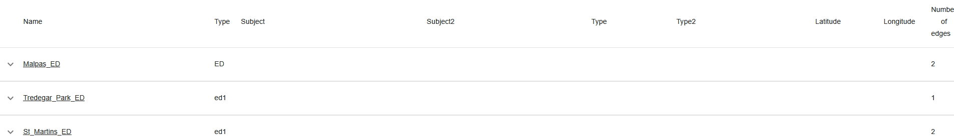

Figure Table with examples of nodes

Example of places in the table:

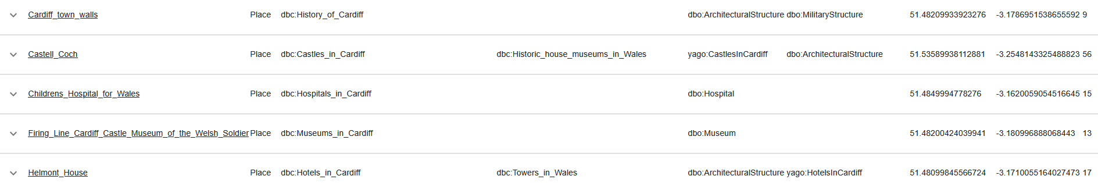

Figure Table with example of place nodes

Example of a place with its edges, this is the collapsible option:

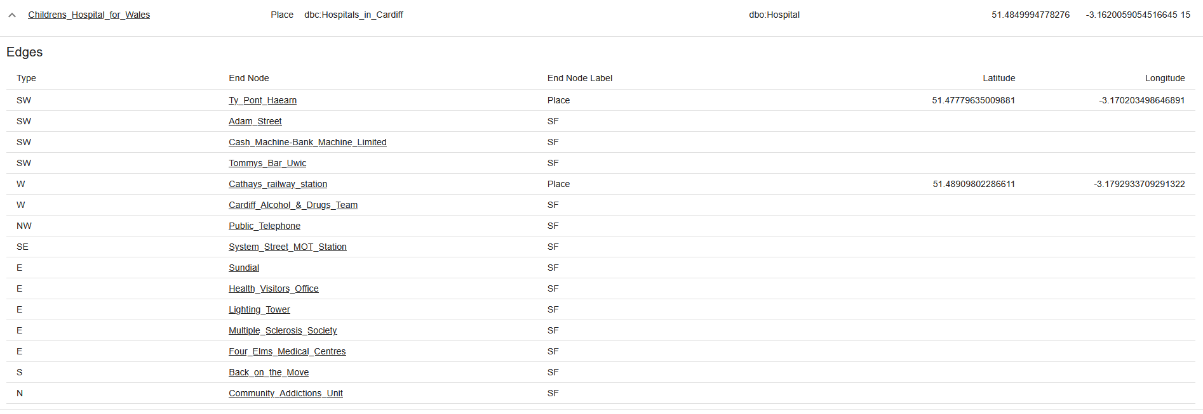

Figure Table with example of expanded node that lists its edges

The input boxes and search button to be dynamically done so in the future, more use cases can be added. Using a dropdown menu option for search type will help in allowing more search options to be added. In this case, all the searches in the use cases to be implemented in this project is done under the dropdown menu.

The Names and End Nodes fields are clickable; this is where a cypher search query will take place to show all the information about the selected node. For example, when selecting Cardiff town walls, it will show all the locations of where the edges related are and the Cardiff town walls too. This is shown in the figure below.

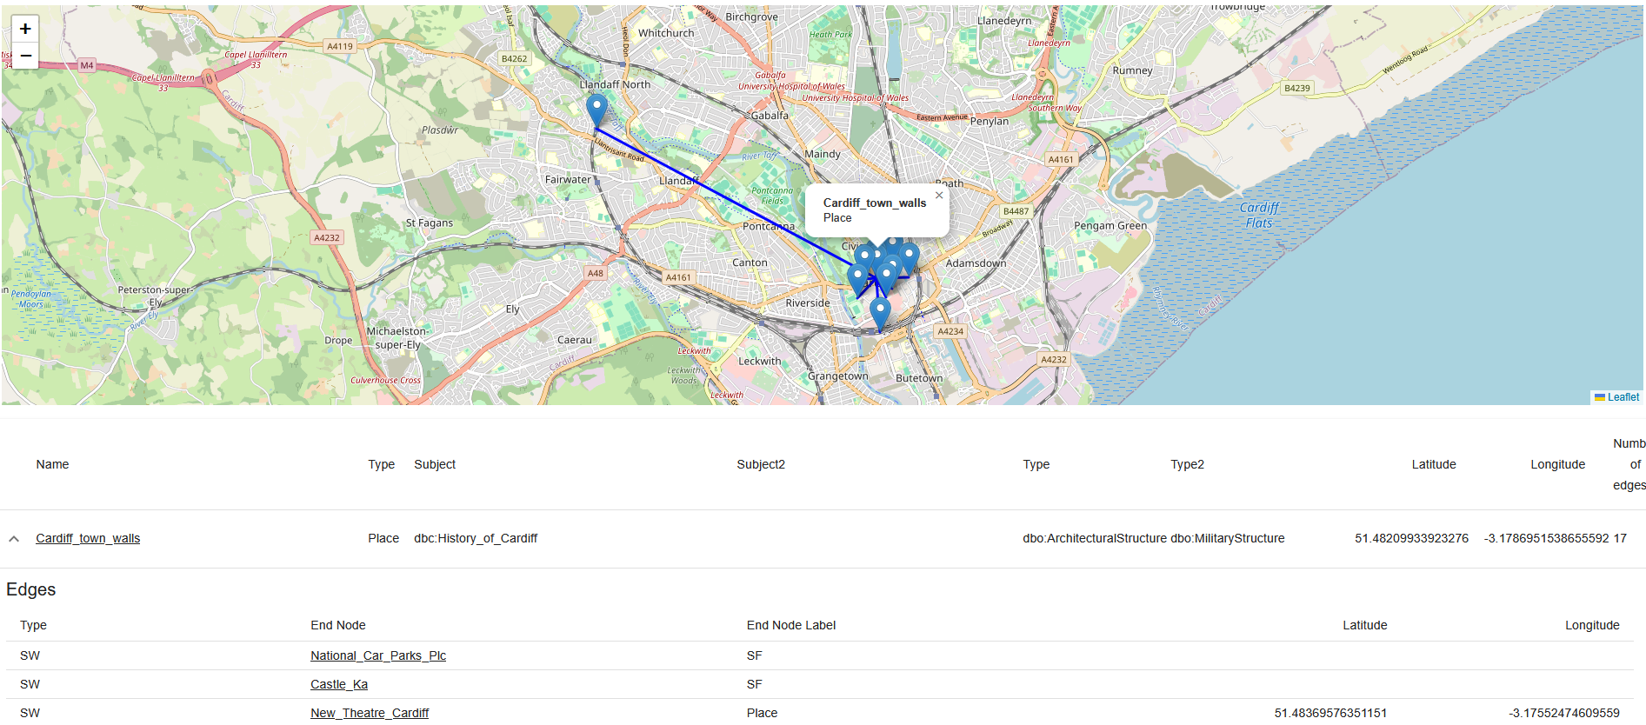

Figure Selecting a node to give more info

The End Nodes are also selectable, for example selecting St David Cardiff shows all the directly related edges with nodes, this is shown in the two figures below.

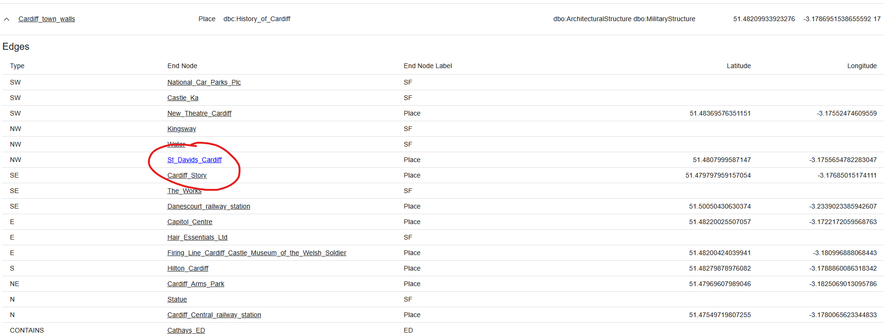

Figure Selectable End Nodes

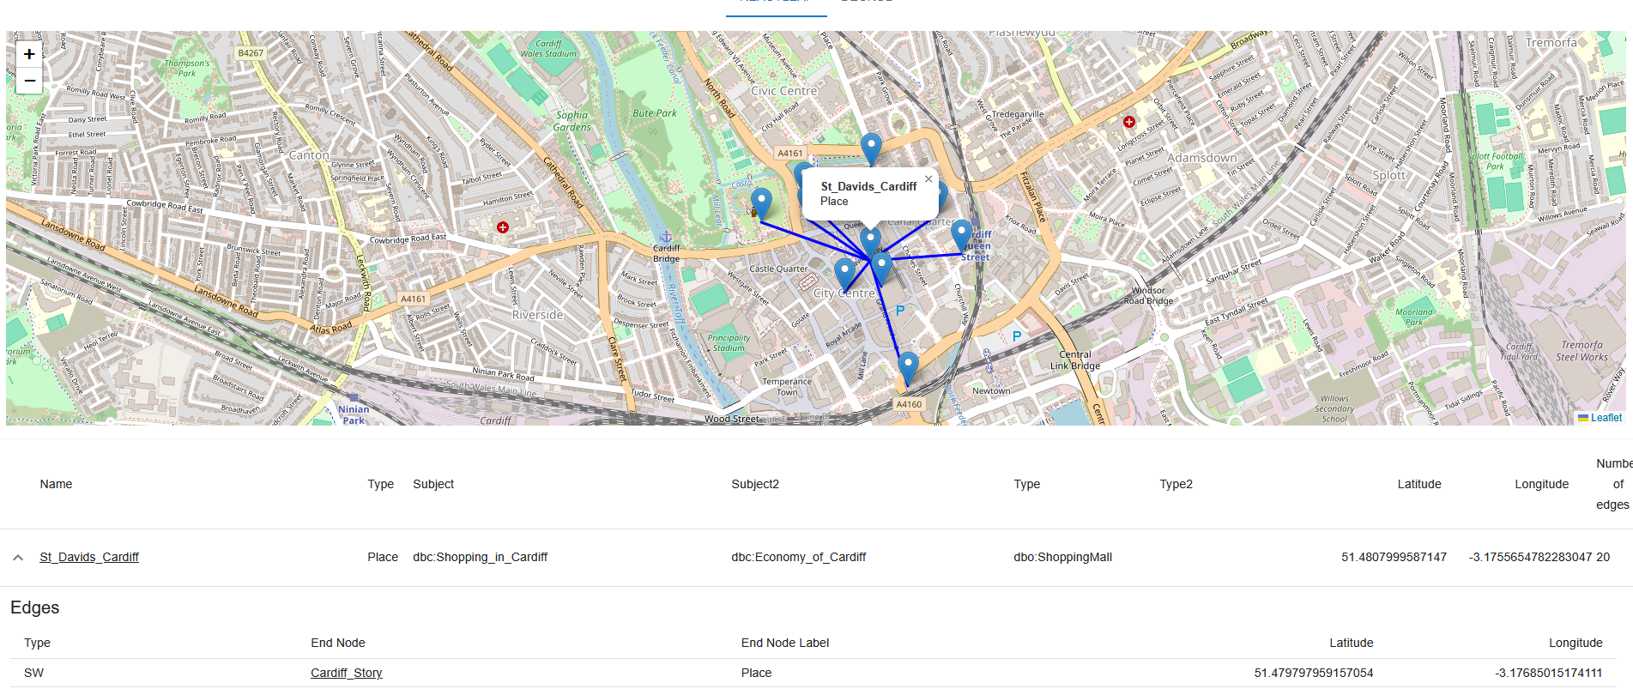

Figure St Davids Cardiff Node Selected

In the figure above where it shows the St David Cardiff, it also shows information on the subject fields which is shopping in Cardiff and Economy of Cardiff with a type of Shopping Mall.

#### Detail Panel

Having a detail panel on the right hand side, showing the details of a selected node on the map. The figure below shows what it looks like when the webpage is loaded for the first time.

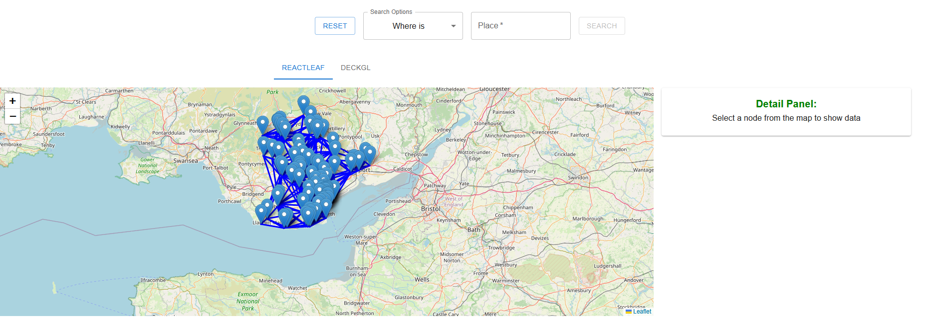

Figure Default View Of Webpage

Showing the details of a selected node is done by clicking on a point in the map. The detail panel will show name, type, location, and properties. It will also show the relationships available. This is shown in the figure below.

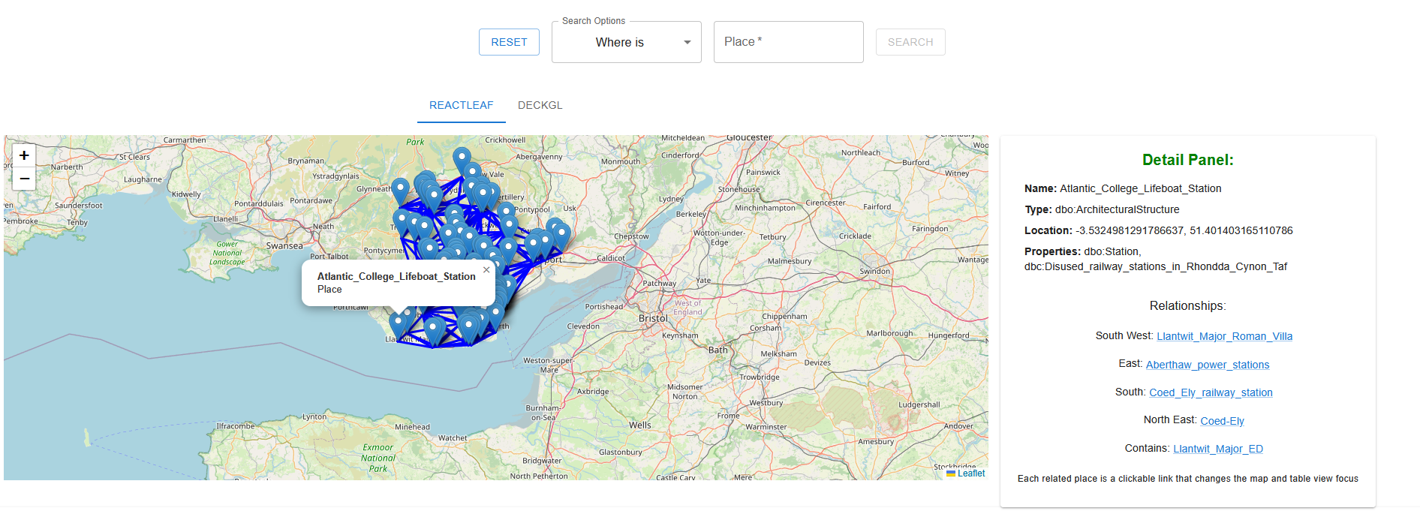

Figure Node Selected, Detail Panel Populated

The relationships appearing is possible because the data is gathered from Neo4J. The node name, type, location, and properties are already available in the point on the map hence passing that data to the detail panel component would be a better choice than having to look for it again in Neo4J. The only missing data would be the edges so, running a cypher query to get the edges of that node which is shown in the figure below.

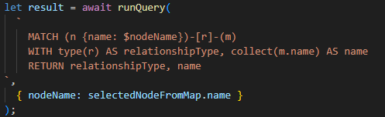

Figure Cypher Query Returns RelationshipType And Name

After receiving the edges and their names, they are already grouped by relationshipType so this would make it easier to show in the detail panel.

Every name in the relationships section is clickable, this does the same functionality as a clickable node name in the table below.

### 5.4.1 Use cases implementation

For the search by place use case, which is the first one, the UI is shown in the figure below where the “Search by Place” option is chosen, and a place can be entered then the search button will be clickable.



Figure Search by Place GUI

This will allow the cypher query to contain all the data that it needs to then be sent to Neo4J to get a result back to ReactJS so then it can be used to display in the graph as listed above and in the map components which will be shown below in section 5.4.3 and 5.4.4.

Implementing suggestions, when the user types a place then a suggested place names would be shown under the input box. For example, if the user types Cardiff then list of places with the name Cardiff would appear. This is shown in the figure below.

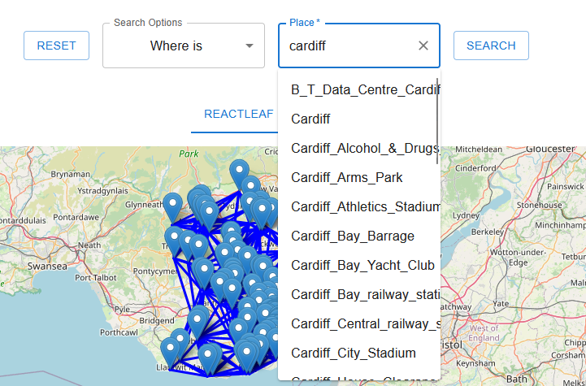

Figure Suggestions under inputbox place

The suggestion uses a component from MUI called Autocomplete. This component takes in the list of data that it would suggest. The suggested data is provided from the result of a cypher query to Neo4J. The Cypher query returns all places’ names shown in the figure below.

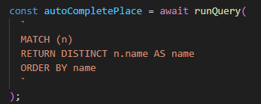

Figure Autocomplete cypher query for places

The second use case which is to search by place, place type and relationship. This is where relationship input field also has suggestions implemented, this is shown in the figure below.

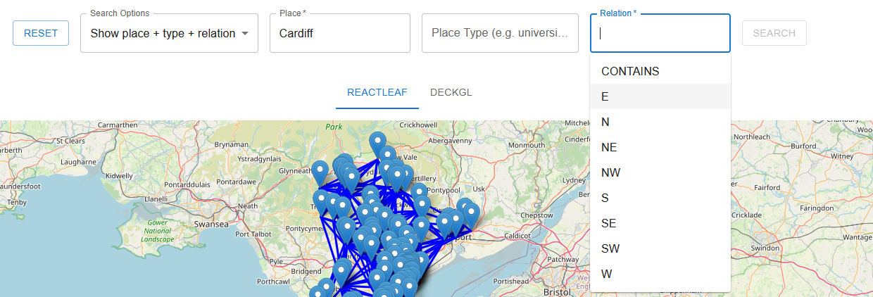

Figure Search by Place, Place Type, and Relationship GUI

This will also do the same functionality when the search button is clickable, this is when the data values are entered which will then enable the search button.

The Reset button is implemented so that the user can reset all the search results and input fields to return the data back to the default which shows all the data. This takes into account what search option the user has chosen and resets the input fields only for that search option.

### 5.4.2 Neo4J Driver

Implementing Neo4J Driver required the installation of driver in ReactJS. Running the following command on the ReactJS project: “npm install neo4j-driver” to install the Neo4J Driver. This will allow the frontend to run queries to the database. The database has the geospatial knowledge graphs. (Neo4j Graph Data Platform, n.d.)

Since the credentials are needed to connect to the Neo4J database, storing the credentials in a secure manner would be necessary. Separating the credentials in a JSON file then by adding the file to the git ignore list, the credentials would never be passed to the git repositories.

Producing a file in components under the folder services for Neo4J service will be useful so that it can be used in the react project. This file has the credentials connection details and the query to send and receive the results from Neo4J. This is shown in the figure below. (Neo4j Graph Data Platform, n.d.)

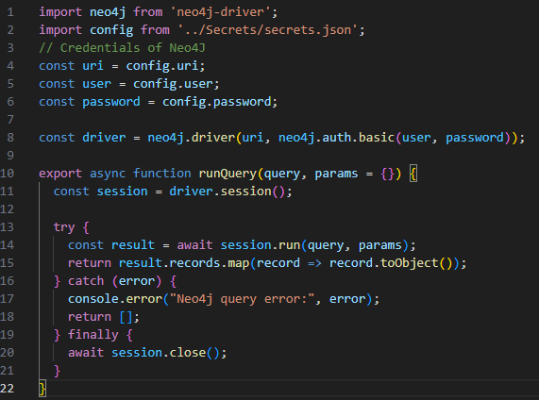

Figure Neo4J driver implementation in ReactJS

The above figure shows the credentials being used to get the driver a session which can then be used to run the query with the parameters to get a result, this might return an error if for example the connection cannot be established so it is shown in the console.

Finally, the session is then closed.

The same cypher query that was made in Neo4J would be implemented in ReactJS, this is shown in the figure below.

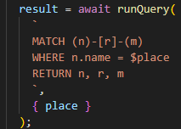

Figure Cypher query in ReactJS

The above figure contains the cypher query for the first use case which is searching by place. This $ symbol represents a parameter of place that will be given by the user then it would be sent to the Neo4J service function which will send all the cypher with the parameter to Neo4J to process and return a result of nodes(n), edges(r), and end nodes(m).

For the second use case, the same cypher query that was used in Neo4J at chapter 5.4 is also used in ReactJS, this returns the same variables of nodes, edges, and end nodes.

More cypher queries can be added since the base functionality is now in place. By adding a search option then checking if that search option is chosen by checking the search type which then can apply the tailored cypher query for that search type to Neo4J.

Having a specific file that does all the Neo4J functionality helps get access to the Neo4J service. This is done by importing the file into a component then utilising the service by sending the cypher query and expecting a result.

### 5.4.3 React-Leaf

Implementing React-Leaf by first installing the components required using “npm install react@rc react-dom@rc leaflet” and “npm install react-leaflet” command. (react-leaflet.js.org, n.d.)

Making a new file in the ReactJS project called ReactLeaf.js, to contain the map, nodes, edges, and sending search cypher queries to the neo4j service function.

Using the MapContainer component from ReactLeaf to show the map with the first node’s coordinates specified and specifying the zoom level which 9 seem to be the ideal zoom level, this can be adjusted by the end user by clicking on the + or – buttons to adjust the zoom level.

The Marker component from ReactLeaf adds the points on the map with the Popup component to add the labels when clicking on the points. Then for the edges, there is a Polyline component from ReactLeaf which takes from and to nodes and has an option to adjust the colour in the code, currently set to the colour blue.

The data of nodes and edges are the results of the cypher query from Neo4J. Then the nodes are loaded using the .map functionality in JavaScript which allows to iterate though the nodes array. In the iteration, there is the repeated Market component that is called on every node that is added. The same logic is done for the edges but with the iteration on the edges array and the repetition of the Polyline component. The end result will look like this figure below.

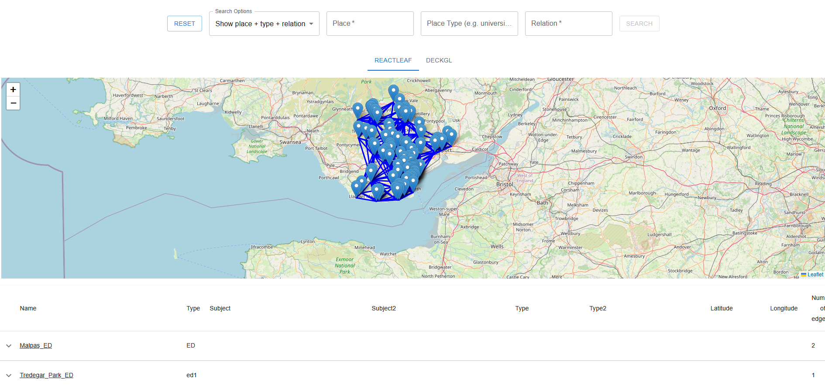

Figure ReactLeaf example map of all data

The map ReactLeaf component would take the following parameters: nodes, edges, nodeMap, loading, set selected node from map.

This data is gathered from Neo4J then processed in ReactJS which then sends it to the map to show. The nodeMap is used for the edges to appear from one node to another. The loading is used to indicate that the data has not returned yet from Neo4J so it shows loading text instead of showing a map with nothing on it. The last one is for the detail panel, when a user clicks on a point in the map, the node data is then sent back to the parent component which sends to the detail panel component to show the details of the selected node.

### 5.4.4 DeckGL

Another type of map component is DeckGL. To install the components, this command is used: “npm install deck.gl –save”. (Deck.gl, 2025) To get it working with the current setup of ReactLeaf, a GUI adjustment must be made to then accommodate both map components. A new component called MapTabs is created which will handle the tabs that can switch between the two map components, this will allow for a comparison of two map components. The figure below shows the tabs.

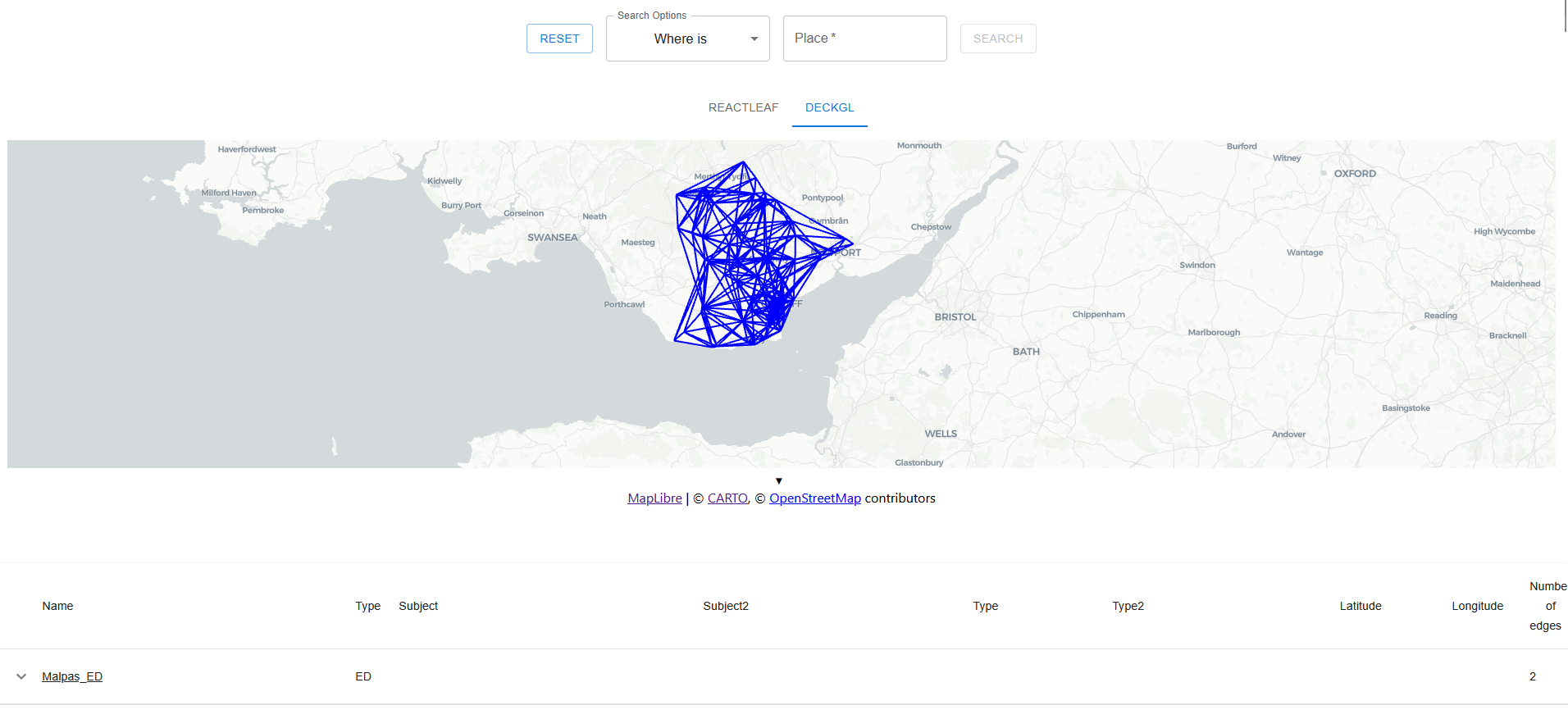

Figure Tabs in ReactJS

The search and results will be in its own custom component, and it will return the result from Neo4J to then send to the map components and the table components. This result data can be used to be sent to other components as well in the future. The DeckGL uses the DeckGL component itself to then show a map using the data from OpenStreetMap. Using layers which are scatter layer and line layer, the scatter layer contains the nodes which plots them on the map using the coordinates of longitude and latitude. The line layer contains the edges which shows the lines between points when they are visible on the map and when there’s a relationship.

# Chapter 6: Analysis and Testing

## 6.1 Analysis

#### Functional – use cases

The use cases implemented in chapter 5.4.1 meet the requirements by producing various search options which accommodate the use cases’ requirements. This is done by having a choice of search options which allows the user to choose from and to do a search with an expected result back. The search options are not limited to the ones implemented since more can be added.

The search section has its own component. There is a variable option called search option. The search option is used to identify which option was chosen from the drop-down menu, once an option is selected, then it identifies which cypher query to choose for the selected search option. Adding another search option would mean to define what data is required then to understand how the cypher query would work best. At the end, adding the search option in the search section component by adding the necessary input fields and cypher query, this will produce a new search option.

#### Data and Visualisation - Accuracy of knowledge graph visualisation

Checking the accuracy of the knowledge graph visualisation of how well the nodes which contain longitude and latitude align on the map is important. This makes sure that the data being used is accurate.

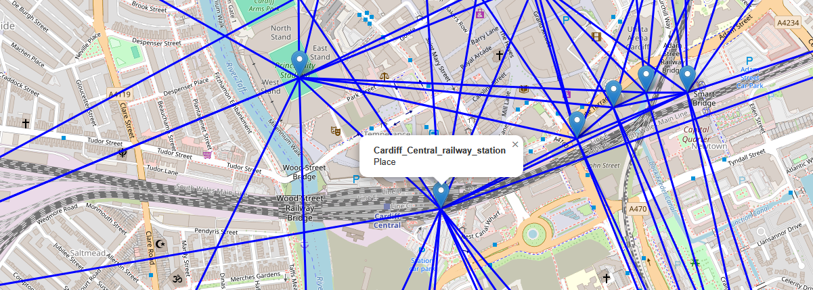

Figure A Point On The Map Demonstrating The Accuracy

In the above figure, this is taken from the ReactLeaf map component and clicking on a place which is Cardiff Central Railway Station. This is accurate, when comparing this to google maps, this shows the exact location of how it is shown in the ReactJS website. The google map is shown in the figure below.

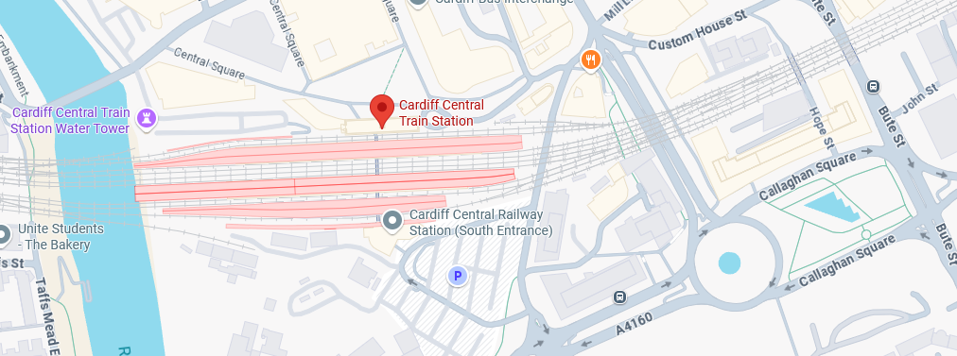

Figure Google Maps - A Point On The Map

#### Usability

Users can view the geospatial knowledge graph data via different views for different reasons. Having a map view gives the places which contain longitudes and latitudes to appear on the map with points and the connections between them to also appear on the map.

The detail panel shows the details of a selected node on the map. This helps the user understand what this point has. For example, clicking on Kingsway Shopping Centre shows the type, properties it has, and the relationships it has. This is shown in the figure below.

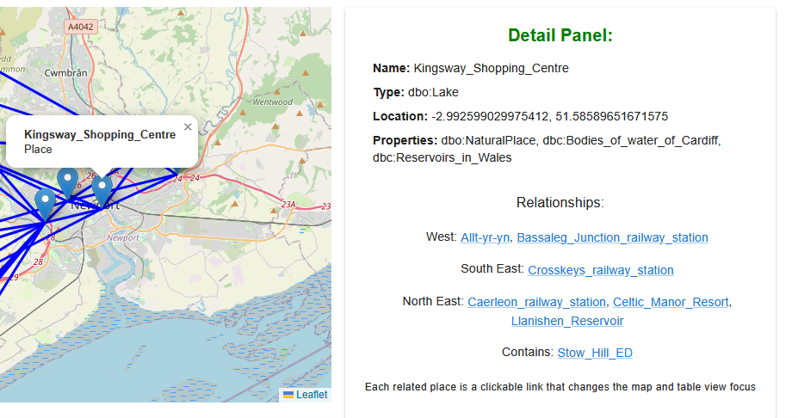

Figure Kingway Shopping Centre - Detail Panel

Every location that is connected with the node that was selected is clickable in the detail panel. This allows for the user to explore locations easier.

The table below shows the information of all nodes and edges that appear on the map. This is shown in the figure below.

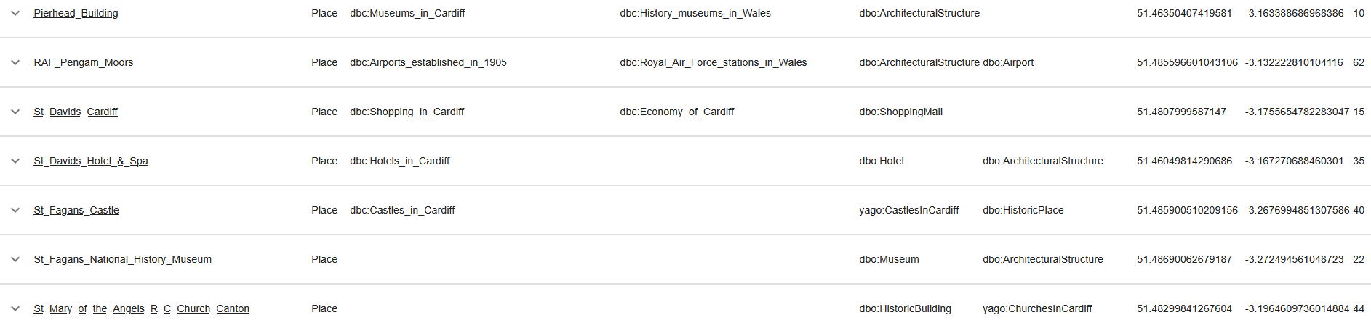

Figure Table - Showing Nodes

By expanding the node, it can show the edges connected to it and the names are all clickable so it will allow the user to explore easier than having to search for it manually.

Overall, usability has been a focus to allow the user to explore the data in more convenient ways than just having one option that does one thing. These features are all interconnected by adapting to what the user clicks or searches.

## 6.2 Testing

#### Map components

Loading the data accuracy, this is coming from Neo4J using the following cypher query in ReactJS, shown in the figure below.

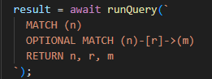

Figure Default Cypher Query

The same cypher query can be applied in Neo4J Aura Query, returns 465 nodes with 2630 edges. The same values are loaded in ReactJS as shown in the figure below.

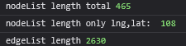

Figure Console Log The Node With/Without Longitude/Latitude And Edge List Length

The same exact values are loaded into ReactJS, the nodes and edges are all available to use. Less nodes are there once they are filtered to places that contain longitude and latitude values since these will be loaded onto the maps of ReactLeaf and DeckGL.

#### Table

The table will contain all the data that is shown on the map plus the points that cannot appear since they do not have longitude and latitude. When searching for Tesco as a place, it shows all the results from Neo4J in the table, shown in the figure below.

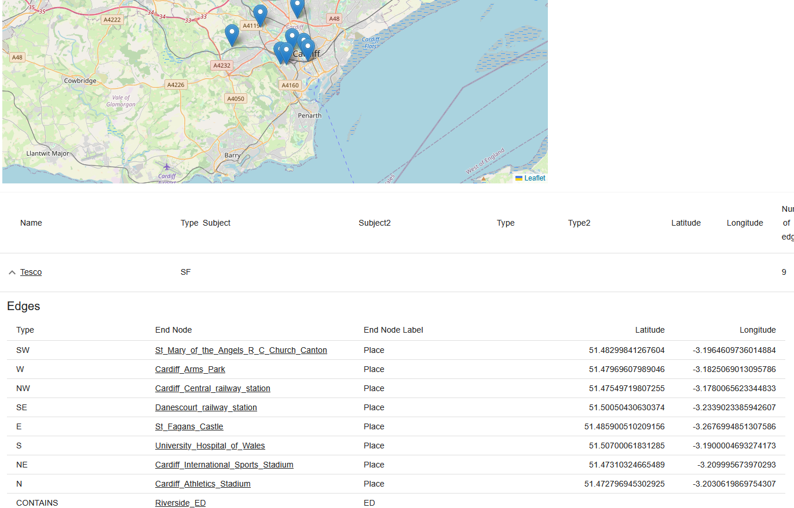

Figure Tesco Search Results

In the figure above there are 8 places with latitude and longitude, the same is reflected on the map above with 8 points appearing. There are two points which do not appear, the node itself of Tesco and the edge node of Riverside, both do not contain longitude and latitude.

#### Detail Panel

The panel shows the information of the selected node on the map. This uses the data provided from Neo4J, either from the default loading all nodes and edges or when performing a search. The edges are loaded from Neo4J after selecting a node, this uses a cypher query. Producing a cypher query in Neo4J to return the results that will appear the same in the detail panel. The figure below shows the Neo4J cypher query and the results of the place “Cardiff_Central_railway_station”.

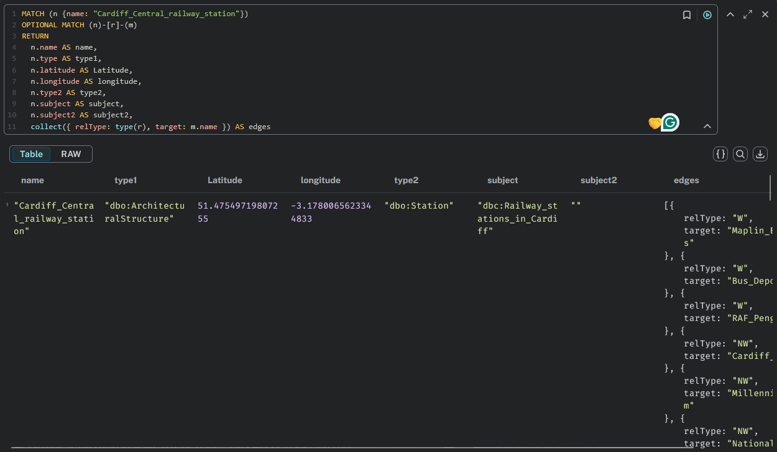

Figure Cypher Query Search By Name

The below detail panel shows the same data as the figure above from Neo4J cypher query.

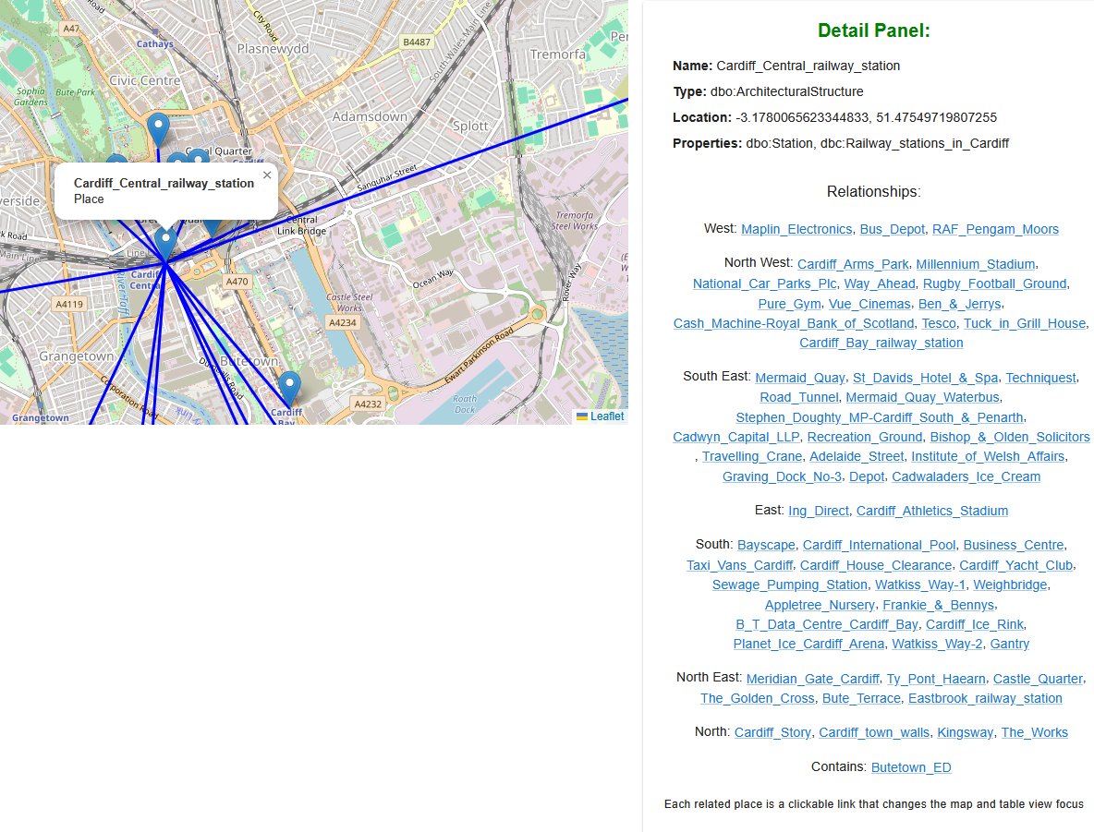

Figure ReactJS Detail Panel Node Selected

The values of both figures above, from Neo4J Aura and from ReactJS Detail Panel match. For example, the type and other properties are the exact same values and the relationships of West are 3 places which also appear 3 places in Neo4J Aura result from the cypher query.

# Chapter 7: Evaluation & Conclusion

## 7.1 Evaluation

Choosing a web framework was difficult decision since there are a lot of very well-made frameworks. ReactJS was chosen because it has a big community backing, meaning it has a lot of third-party libraries. This is beneficial for this project since it utilises GUI components, it is essential to visualise the geospatial knowledge graph in various unique ways. GUI was generally done by material UI, which is based on google material UI. The library has a wide range of options that the developer can choose from hence the expandability can be achieved by choosing MUI library. Implementing them was not difficult since clear instructions are provided on MUI’s official website. Documentations also include live demonstrations of most GUI components offered.

There are many database options available for managing geospatial knowledge graphs. Comparing database solutions by researching what is the best choice for this project. The project required a simple yet effective database solution. Effective meaning that the database is made to handle knowledge graphs, especially geospatial data. Utilising the relationships between the nodes is a minimum requirement. Neo4J has all the checkboxes checked for this project by providing a robust, reliable, and well maintained since it also needs to be accessible in ReactJS. ReactJS can access the Neo4J database directly by using the Neo4J-driver library provided by Neo4J. This made the implementation much easier and quicker than implementing a backend API.

Importing the data into Neo4J was not straightforward since the data was in csv format. Converting them required using a simple yet effective Python script. Producing 2 JSON files that contain nodes and edges which then can be imported easier into Neo4J. By checking the data integrity, it assures that they are maintained throughout the process of converting and importing. At the end, the data is shown in ReactJS website. Also checking if the data is correct by having a cypher query get the results, running it directly in Neo4j Aura and comparing the results with the data that appears on the website.

Representing the data on the ReactJS website was done in different ways. Map, table, and detail panel. The map shows the locations by having points with edges appear, helping the user to get a good picture of where are the locations shown. The table gives more information since not all the data has coordinates, allowing the user to see all the data plus the missing ones from the map. Detail panel gives more information on the selected point on the map. If the user would like to know more about a location on the map, they can click on it and detailed information would appear, giving the user a better understanding of locations. Having search options on the website gives the user the power to filter what locations they want to see, this gives the user three search options, search for: a place, a place plus type, a place plus type plus relation. The result of the search is reflected on the map and table.

More GUI capabilities could be implemented since the MUI library has many more components. And more search options can be added where the ReactJS code has been done in such a way that more options can be easily added without having to modify any of the code significantly. This was done so the project can be further developed in the future, with numerous possibilities for extension.

## 7.2 Conclusion

Meeting the overall aim first required achieving the individual objectives. The first objective is to understand what it takes to create a webapp that has the capability of visualising a geospatial knowledge graph, this was achieved by the background research that was done. Exploring the possible web frameworks that contain features such as scalability, easy to develop where it does not compromise on expandability. Assessing an existing product such as kepler.gl which shows geospatial knowledge graphs provided valuable insights into the requirements and expectations of end users in terms of usability and functionality.

The second objective is to compare different types of visuals that represent the geospatial knowledge graph. The objective was achieved by implementing two maps by using different libraries, a table that shows the data in more detail, and a detailed panel. Having three different types of visual components integrated into the webapp provides the end user with various possible solutions. Analysing and testing each visual type was done to verify the accuracy of the data since there were numerous steps taken to making the data usable.

Comparing web frameworks is the third objective which was achieved by researching several possible frameworks. There were some requirements to be met, spending less time on developing the website but more time on implementing the required components, enabling the project to have numerous unique visuals implemented. Not compromising on quality of the code by having the possibility of adding different visual types, can be accomplished through having the data readily accessible throughout the code and each visual type has a separate component making it loosely coupled.

The final objective is to test the web application using the knowledge graph data. This can be done once the data is available, allowing the verification of its accuracy. Comparison with the Neo4j data can be performed both on the website and directly in the database. The testing was completed successfully, confirming that the data is correct. Checking the maps implemented, a comparison was done with well-known existing map, Google Maps.

To conclude, a well-structured and functional code has been developed, enabling future implementation and demonstrating the geospatial knowledge graph using various techniques to address the end-user queries.

# Chapter 8: Future Work

# Chapter 9: Reflection

# References

Create-react-app.dev. (2019). Create React App · Set up a modern web app by running one command. [online] Available at: https://create-react-app.dev/docs/getting-started/ [Accessed 25 Jul. 2025].

Deck.gl. (2025). Installing and Running Examples | deck.gl. [online] Available at: https://deck.gl/docs/get-started/getting-started [Accessed 7 Aug. 2025].

Giri, N. (2024). Best 7 React UI Libraries for 2024. [online] Nishangiri.dev. Available at: https://nishangiri.dev/blog/best-react-ui-library [Accessed 4 Aug. 2025].

Github.io. (2019). Transformer - pyproj 3.7.1 documentation. [online] Available at: https://pyproj4.github.io/pyproj/stable/api/transformer.html [Accessed 29 Jul. 2025].

Graph Database & Analytics. (2024). Neo4j Pricing. [online] Available at: https://neo4j.com/pricing/#graph-database [Accessed 26 Jul. 2025].

Guo, D. and Onstein, E. (2020). State-of-the-Art Geospatial Information Processing in NoSQL Databases. ISPRS International Journal of Geo-Information, 9(5), p.331. doi:https://doi.org/10.3390/ijgi9050331.

Ji, S., Pan, S., Cambria, E., Marttinen, P. and Yu, P.S. (2022). A Survey on Knowledge Graphs: Representation, Acquisition, and Applications. IEEE Transactions on Neural Networks and Learning Systems, [online] 33(2), pp.494–514. doi:https://doi.org/10.1109/TNNLS.2021.3070843.

kepler.gl. (2019). Large-scale WebGL-powered Geospatial Data Visualization Tool. [online] Available at: https://kepler.gl/ [Accessed 12 Jul. 2025].

Li, W., Wang, S., Chen, X., Tian, Y., Gu, Z., Lopez-Carr, A., Schroeder, A., Currier, K., Schildhauer, M. and Zhu, R. (2023). GeoGraphVis: A Knowledge Graph and Geovisualization Empowered Cyberinfrastructure to Support Disaster Response and Humanitarian Aid. ISPRS International Journal of Geo-Information, [online] 12(3), p.112. doi:https://doi.org/10.3390/ijgi12030112.

mui.com. (n.d.). Installation - Material UI. [online] Available at: https://mui.com/material-ui/getting-started/installation/ [Accessed 1 Aug. 2025].

Neo4j Graph Data Platform. (n.d.). Build applications with Neo4j and JavaScript - Neo4j JavaScript Driver Manual. [online] Available at: https://neo4j.com/docs/javascript-manual/current/ [Accessed 25 Jul. 2025].

Node.js. (n.d.). Download. [online] Available at: https://nodejs.org/en/download [Accessed 25 Jul. 2025].

Pourabbas, E. (2025). Geographical Information Systems. [online] Google Books. Available at: https://books.google.co.uk/books?hl=en&lr=&id=dcuSAwAAQBAJ&oi=fnd&pg=PA73&dq=neo4j+geospatial&ots=G8ASJx9DE3&sig=a1MSTyvYGB69fC7Liq8WX97iZX8&redir_esc=y#v=onepage&q&f=true [Accessed 14 Jul. 2025].

Rajiv Tulsyan, Shukla, P., Singh, T. and Kumar, A. (2024). The Impact of JavaScript Frameworks on Website Performance and User Experience. [online] pp.299–305. doi:https://doi.org/10.1109/icbdml60909.2024.10697529.

react-leaflet.js.org. (n.d.). Introduction | React Leaflet. [online] Available at: https://react-leaflet.js.org/docs/start-introduction/ [Accessed 14 Jul. 2025].

support.google.com. (n.d.). About knowledge panels - Knowledge Panel Help. [online] Available at: https://support.google.com/knowledgepanel/answer/9163198?hl=en [Accessed 12 Jul. 2025].

# List of Figures

Figure 1 Sample data loaded in Kepler.gl 7

Figure 2 Layer example in Kepler.gl 8

Figure 3 Design Demo Of Website 13

Figure 4 Converted x and y to latitude and longitude 14

Figure 5 Neo4J Graph Model 14

Figure 6 Neo4J Aura Cloud Instance 16

Figure 7 Neo4J Empty Graph Model 17

Figure 8 Nodes Python Script Converter 18

Figure 9 Relationship Python Script Converter 19

Figure 10 Load nodes.json into Neo4J cypher query 19

Figure 11 Nodes in Neo4J without edges 19

Figure 12 Load relationships.json into Neo4J cypher query 20

Figure 13 Sample relationship import data into Neo4J 20

Figure 14 All nodes and edges in Neo4J 21

Figure 15 Nodes by themselves in Neo4J 21

Figure 16 Incorrect data in ED_SF_OtherPoint_Containment.csv 22

Figure 17 Use Case 1 cypher Query 22

Figure 18 Use Case 1 Cypher Query Output 23

Figure 19 Use Case 2 Cypher Query 23

Figure 20 Use Case 2 Cypher Query Output 24

Figure 21 Use Case 3 Cypher Query 24

Figure 22 Use Case 3 Cypher Query Output 25

Figure 23 Table with examples of nodes 26

Figure 24 Table with example of place nodes 26

Figure 25 Table with example of expanded node that lists its edges 27

Figure 26 Selecting a node to give more info 27

Figure 27 Selectable End Nodes 28

Figure 28 St Davids Cardiff Node Selected 28

Figure 29 Default View Of Webpage 29

Figure 30 Node Selected, Detail Panel Populated 29

Figure 31 Cypher Query Returns RelationshipType And Name 29

Figure 32 Search by Place GUI 30

Figure 33 Suggestions under inputbox place 30

Figure 34 Autocomplete cypher query for places 31

Figure 35 Search by Place, Place Type, and Relationship GUI 31

Figure 36 Neo4J driver implementation in ReactJS 32

Figure 37 Cypher query in ReactJS 32

Figure 38 ReactLeaf example map of all data 34

Figure 39 Tabs in ReactJS 35

Figure 40 A Point On The Map Demonstrating The Accuracy 36

Figure 41 Google Maps - A Point On The Map 37

Figure 42 Kingway Shopping Centre - Detail Panel 37

Figure 43 Table - Showing Nodes 38

Figure 44 Default Cypher Query 38

Figure 45 Console Log The Node With/Without Longitude/Latitude And Edge List Length 38

Figure 46 Tesco Search Results 39

Figure 47 Cypher Query Search By Name 40

Figure 48 ReactJS Detail Panel Node Selected 40

# Appendices

## Appendix A - GitLab Project, contains the converters, ReactJS webapp, csv, json files, instructions on how to run the project

<https://git.cardiff.ac.uk/student-projects/msc-projects/zeilaa-2025>

## Appendix B – Gantt Chart, project plan

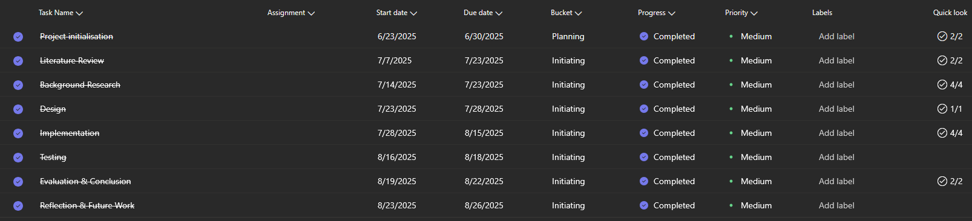

## Appendix C – Meeting notes

